Faculty Guide for Implementing Academic Accommodations

Introduction
This guide provides faculty with more detailed information regarding the implementation of accommodations at the University of Northern Iowa. This is not an exhaustive guide so faculty should contact Student Accessibility Services with any additional questions or concerns.

Student Accessibility Services and the University of Northern Iowa believe that disability is a naturally occurring aspect of humanity’s diversity and is an integral part of society and this University.

We believe in working collaboratively with students, faculty, and staff to provide accessible and equitable opportunities for all students.

Contact Information
Student Accessibility Services
University of Northern Iowa
118 Gilchrist Hall
Cedar Falls, IA 50614
Phone: 319-273-2332
Fax: 319-273-5832
Email: accessibilityservices@uni.edu

Tiffany Dodd
Assistant Dean of Students - Student Accessibility Services
319-273-2332
tiffany.dodd@uni.edu

Rebecca Costleigh
Student Accommodation Specialist
319-273-2332
rebecca.costleigh@uni.edu

Michelle Galanits
SAS Testing Clerk III
319-273-3926
sastesting@uni.edu

Allyson Rafanello
Assistant Vice President & Dean of Students
319-273-2332
allyson.rafanello@uni.edu

Disability Law & Higher Education
The following items summarize key features or components of ADAAA/504 Requirements of postsecondary institutions as well as outlining the general process for determining eligibility for accommodations.

Purpose of the Law
The purpose of the law is to provide an alternative way to accomplish the course requirements by eliminating or reducing disability-related barriers.
“Reasonable accommodations” are not intended to lower course standards or alter degree requirements; provide equal access and opportunity “level the playing field”; and cannot place an undue burden on institutions.
The term “reasonable accommodations” refers to the aids, benefits, and services that afford persons with disabilities the opportunity to obtain the same result, gain the same benefit, or reach the same level of achievement in the most integrated setting appropriate to the person’s needs. (Rehabilitation Act of 1973, Section 504, https://www2.ed.gov/about/offices/list/ocr/docs/auxaids.html)

Scope of Responsibility
ADAAA and Section 504 of the Rehabilitation Act are civil rights laws that prohibit discrimination in college recruitment, admission, or treatment of students with disabilities. Programs, courses, field trips, internships, practicum sites, as well as services, activities, and facilities must be accessible to people with disabilities.

Coordination of Services
Each University must designate a person/department responsible for the coordination and provision of disability-related services.

Interactive Process
The institution and the student have a shared responsibility for the provision of accommodations. The college and its staff must provide accommodations in a timely, effective manner at no cost to the student. The student must notify the appropriate university staff of a disability if accommodations are needed. An interactive, coordinated approach between the student and university staff is vital.

Confidentiality
The University cannot make pre-admission inquiries regarding an applicant’s disability status. Students have privacy and confidentiality protections. Disability-related information should be maintained separate from the student’s official file. In accordance with FERPA (Family Educational Rights and Privacy Act) regulations, disability information is protected and access should be limited.

Documentation of Disability
The University can require appropriate documentation of a disability if a student requests disability-related accommodations. The student has responsibility for disclosing and providing documentation of the disability.

Determination of Disability
Any student who has a physical or mental impairment that substantially limits a major life activity (when in comparison with their peer group) is considered disabled and therefore eligible for accommodations.

Determination of Accommodations
An accommodation is an alteration to the academic environment to ensure students with disabilities have equitable access to course materials, information, activities, programs, and campus facilities. Students are not guaranteed accommodations because they have a diagnosis or disability. Determination of appropriate accommodations (type and level) for a qualified person with a disability is a primary responsibility of Student Accessibility Services (SAS). Students with disabilities are encouraged to connect with SAS to begin the individualized process of determining reasonable accommodations, based on the nature of the disability and the academic environment. The student's past accommodations history, and supporting documentation related to their disability are taken into consideration when making accommodation determinations.

Students might request accommodations directly from an instructor. In this case, the student should be given the contact information or directly referred to Student Accessibility Services.

Instructors are encouraged, when in doubt, to contact Student Accessibility Services to seek clarification for any questions related to a student’s accommodations. We encourage strong communication among instructor, student, and Student Accessibility Services staff.

Implementation of Accommodations
Individualized accommodation plans are shared with appropriate faculty and staff, typically through an Accessibility Letter, for facilitating equitable access; specific disability information is not shared without expressed permission. Faculty are required to implement the accommodations outlined in the Course Accessibility Letter, effective upon email notification of the Accommodations Letter. Faculty can access Course Accessibility Letters via the Faculty Interface of Accommodate.
Reasonable accommodations provide equitable access to educational programs and activities; they do not lower course standards, provide an unfair advantage, or fundamentally alter program requirements. If you feel that a specific accommodation fundamentally alters your course requirements, refer to the information on page 10 of this guide.
Faculty Office Hours
In an attempt to better serve faculty and students, SAS staff will be holding regular office hours each week designated as a time to engage with faculty via email, phone, zoom, or in person meetings regarding the implementation of accommodations. For the most up to date information on the scheduled office hours, please visit the SAS website.

Guidelines for Implementing Accommodations
Once a faculty member receives the accommodation letter notification for a student, the accommodations are considered effective and need to be implemented by the faculty member. Students are encouraged to meet with faculty to discuss accommodation implementation specifics but they are not and cannot be required to. Faculty should provide all accommodations as stated in the letter unless a student emails both the instructor and Student Accessibility Services to indicate that they will not be using a particular accommodation.
In order to best serve instructors, recognizing the complexity of language and/or implementation, SAS has outlined several accommodations in more detail than what is found in the accommodations letter. This document will serve as a centralized location for answers to frequently asked questions and will be updated each semester.

Implementation of Specific Accommodations

Attendance Accommodations Guidelines
Some disabilities may impact a student’s ability to attend class in-person.

Occasional Virtual Attendance
- Some disabilities may impact a student’s ability to attend class in-person during inclement weather.
- Inclement weather for the purposes of this accommodation is typically defined as heavy snowfall, ice, and below 0℉ temperatures (with or without windchill).
- Faculty members should be prepared to provide the student with a zoom link for class, particularly during inclement weather.
- Students need real-time access to the content being lectured on or presented to the entire class. This both ensures equitable access to the content but also timely access. This does not mean a faculty member needs to be on screen the entire time, nor does it mean the student needs to be able to fully participate.
  - If a student with this accommodation is in a lab course, the instructor should connect with Student Accessibility Services to discuss the logistics of this accommodation.
- Students should communicate with faculty members via their UNI email as soon as they are aware they will need to miss class due to weather.

Virtual Attendance
- A student may require virtual access to a course due to their disability.
- Student Accessibility Services and course faculty will discuss course specifics to determine whether this is a reasonable accommodation. Based on that conversation, an accommodation will be determined.
- The specifics of that conversation will be summarized in an email and provided to the student and faculty to ensure all parties are aware of the expectations.

Extended Absences
- SAS encourages students to connect with us early in the semester to best apply this accommodation.
- Students are encouraged to use this responsibly and in a manner that does not put them behind in coursework.
- This accommodation applies to in-person courses and synchronous online courses.
- Extra absences are provided based on the number of times the course meets per week. These extra absences are provided in addition to any allowable absences per the course syllabus.
  - 1 class/wk = 1 additional absence
  - 2 classes/wk = 2 additional absences
  - 3 classes/wk = 3 additional absences
- This accommodation is applied from the date the faculty receives the letter, forward. It is not retroactive.
  - For example, if a student receives this accommodation in August, the accommodation is applied to the whole semester. If a student receives this accommodation in November, the accommodation is applied from that date forward. Any previous absences remain and this accommodation is not applied to them.
- If a student feels their disability needs are not met through the additional absences listed above, they are encouraged to connect with SAS to discuss additional absences or alternative accommodations.

Note Taking Accommodations
- Many of the note taking accommodations center around the option to audio record lectures.
  - Students do not need to request permission or notify faculty/peers if they are audio recording.
  - Students may be using a smartpen, computer software, audio recorder, or personal electronic device to audio record during class.
- In order to implement the note taking accommodation, “Access to Presentation Slides”, faculty should email Presentation Slides (if they are used in your course) to the student 24 hours prior to 8:00 am on the course meeting date.
  - However, if you provide the presentation slides to the entire class via BlackBoard, email that information and the link to the materials once you receive the accommodations letter. You will need to ensure the slides are posted 24 hours prior to 8:00 am on the course meeting date.

Test Related Accommodations Guidelines
Some students have disabilities that require a testing environment with few or negligible sensory distractions which results in the accommodation “Distraction Reduced Exam Setting or Individual Distraction Reduced Exam Setting”. Some students have both the distraction reduced environment accommodations and extended testing time. It is important to note, all students with extended testing time accommodations are required to test in a separate testing environment from the classroom, either with faculty or with the SAS Testing Center. Students should test at the SAS Testing Center when their testing accommodation indicates “with SAS” (i.e. Distraction Reduced Exam Setting with SAS).

Distraction Reduced Exam Setting Environment:
- May include other students testing at the same time.
- Should have few to no windows that could lead to distractions.
- Should be relatively soundproof i.e. the door cannot be left open to the hallway.
- Should be relatively clean and free of clutter i.e. not a place of storage.
- Must have access to a chair with and without arms as well as a chair that is not on wheels.
- Requires access to a sound machine and sound-proofing headphones.

Individual Distraction Reduced Exam Setting Environment:
- Must be a separate space, free of distractions and other individuals.
- Other individuals should not have access to come and go from the same space during the exam.
- Should have few to no windows that could lead to distractions.
- Should be relatively soundproof i.e. the door cannot be left open to the hallway.
- Should be relatively clean and free of clutter i.e. not a place of storage.
- Must have access to a chair with and without arms as well as a chair that is not on wheels.
- Requires access to a sound machine and sound-proofing headphones.
If you do not feel you can provide access to an environment meeting these guidelines, students should test with SAS Testing. Faculty should email both the student and SAS Testing notifying both parties of this adjustment.

SAS Testing Center Guidelines and Processes

SAS Testing Center Process (8:00 - 4:30, M - F)
- Students will request a test appointment with Student Accessibility Services through Accommodate (online).
  - Students will receive an email confirming the approved/declined request.
  - Please note that the student may have a class schedule that conflicts with the ability to take an extended time test at the same time as the scheduled course, they can schedule at an alternative time (not before the test date and time) that allows them the full testing time.
  - Students also receive a reminder email 1 day prior to the student’s scheduled appointment.
- If the request is approved, instructors will receive an email notifying them of the Student Name and ID, Scheduled Date/Time, and the Course Title.
  - The email also has a link to the SAS Testing Accommodations Faculty Form which will prompt instructors to attach the test and relevant materials.
  - Faculty also receive a reminder email 1 day prior to the student’s scheduled appointment.
- If the request is declined, students will automatically receive an email letting them know they need to pick a different day/time to test. It will also provide SAS Testing contact information so they can call with any questions or concerns.
- If SAS Testing Accommodations staff have not received a test at the time of the student’s scheduled appointment, the student will be permitted to reschedule the test to a later date based on their schedule.
  - As to best serve students, instructors will then receive an email request asking for the completed SAS Testing Accommodations Faculty Form to be submitted within one business day.

Faculty Role in the SAS Testing Process
- Review all received accommodations letters and note the students with testing accommodations. If students are to test with SAS, complete the following steps for each test or quiz.
- Complete the online SAS Testing Accommodations Faculty Form. (The same link is used for all students throughout the semester).
  - Attach the test or tests and any relevant materials via the Google form.
  - Submit the Form at any point in the semester as long as it is submitted at least 2 business days prior to the student’s scheduled test date and time.
  - If based on the nature of the test, it must be delivered to SAS Testing in a hardcopy format, please email SAS Testing.
- After the test or quiz is completed, SAS Testing staff will scan the test, relevant materials, and any additional approved documents the student provides.
  - All exams will be returned electronically within two business days, unless specifically requested via email by the individual instructor for a specific course.
  - If a faculty member requests to pick up the completed tests, SAS Testing staff will notify the instructor within two business days that their exams have been scanned and can be picked up at Gilchrist 013.
    - Faculty will date and sign the SAS Testing Cover Sheet for recordkeeping purposes.

Student Role in the SAS Testing Process
- Review their syllabi and/or Blackboard to determine test dates.
- Submit requests for all test dates for each class through Accommodate. When possible, test at the same time as the rest of the class; however, if they can’t due to their course schedule or school related commitments, they should try to test within 24 hours.
  - If a test date changes, cancel that testing appointment and schedule a new testing appointment.

Test Security Measures
- Students check-in with SAS Testing staff prior to entering a testing room. Students will provide staff their name, student ID#, and a photo ID. We encourage students to bring their UNI Student ID because it provides their name, student ID#, and a photo. Students will provide any belongings (including electronic devices like smartwatches and phones) to the SAS Testing staff to be locked up.
- Students are verbally reminded of SAS Testing basic rules and guidelines.
  - Testers are not to have any personal electronic devices in the testing room without approval from the SAS Professional Staff and/or confirmed approval from the instructor.
  - The test rooms are under video surveillance so if they have a question or need something, they can raise their hand and a staff member will come to assist them.
  - If a tester is found with any unauthorized materials or devices, the Professional Staff will immediately stop the test, take the test from the student (if it is hardcopy), and return any of the tester’s belongings. Professional or Student staff will complete the check-out sheet on behalf of the tester once their belongings are returned and they have left the room. The Professional staff will then scan the test and any materials and email them to the course instructor and the Assistant Dean of Students - SAS with a summary of the situation.
- All tests are kept in a locked cabinet in a locked office
- For the 2023-2024 academic year, SAS will purge all test related material provided by faculty 1/31/24 and 6/30/24.

Fundamental Alteration Process
Through Section 504 of the Rehabilitation Act of 1973, Title II of the ADAAA, various Department of Justice cases, and several Office of Civil Rights case resolutions, the federal government has clarified that colleges and universities must:
- engage in an individualized, interactive process with each student request for accommodations and avoid blanket statements or policies regarding accommodations (OCR No. 10-16-2203),
- understand the student must not be put in the place of requesting their accommodation more than once and must not be left to negotiate their accommodation with faculty which compromises the interactive process and is further compromised because of the disparity in power and authority between a student and a professor who ultimately assigns a student grade (OCR No. 01-16-2113, OCR No. 01-16-2120)
- understand that academic adjustments and reasonable modifications for student with disabilities are determined only by the appropriate University office, and that such academic adjustments and reasonable modifications cannot be altered by faculty or administrators (OCR No. 01-23-2011)
- understand the decision of whether a specific standard or requirement is an essential program requirement that cannot be modified must be educationally justifiable and be essential to the educational purpose or objective of a program or class. OCR policy requires:
  - the decision be made on a case-by-case basis considering the specific disability-related accommodations requested by the student for the course/program at issue (OCR No. 15-21-2136);
  - The decision be made by a group of individuals, which shall include Student Accessibility Services (SAS) staff and pertinent faculty, who are trained, experienced, and/or knowledgeable about the course or program in question (OCR No. 01-16-2120; OCR No. 15-12-2118 and 15-13-2011; OCR No. 15-21-2136);
  - the group pursues a thoughtful, careful, rational review of the academic course/program essential requirements and objectives and available options/alternatives (OCR No. 01-16-2120, OCR No. 15-21-2136);
    - Mere reliance upon tradition or existing rules may well not be a sufficient justification for refusing to implement a requested accommodation (Southeastern v. Davis , PGA vs. Martin)
  - SAS staff document the decisions and delineates the reasons an accommodation would lower essential academic standards, fundamentally or substantially modify the course or academic program in question, constitute the provision of personal services, pose an undue burden for the University, or is otherwise not required by Section 504 or Title II (OCR No. 01-16-2120; OCR No. 15-12-2118 and 15-13-2011; OCR No. 15-21-2136)
- Provide that should a disability-related request for accommodation be denied because it would result in a fundamental alteration, that the University (SAS) will engage in a deliberative process with the student to determine what, if any alternative accommodations may be provided to effectively address the student’s disability-related needs (OCR No. 01-16-2120, OCR No. 15-21-2136);
- Make any determinations related to essential requirements and accommodations in a timely manner and provide it in writing to the student as to allow sufficient time to obtain alternative accommodations and prior to the conclusion of the course add-drop period (if possible) should the original request be denied (OCR No. 15-21-2136, OCR No. 15-12-2118 and 15-13-2011).

University of Northern Iowa Procedure
If a faculty member has a concern with how to implement an accommodation in their course, the first step is to engage with the Assistant Dean of Students - Student Accessibility Services in an interactive conversation either in person, via Zoom, or over the phone. This may include discussing whether an accommodation (as it is written) fits with the logistics of your course, teaching style, University legal obligations, any challenges in implementation for the specific course, any questions surrounding general implementation, amongst others.

After this discussion, if the faculty member continues to have concern that the student’s specific accommodation may fundamentally alter that particular course, program, or essential requirement, the faculty member should initiate the Fundamental Alteration Procedure by completing the online form. Once the form is received, the Assistant Dean of Students - Student Accessibility Services will engage in the following process:

- The Assistant Dean of Students for Student Accessibility Services will involve a group of individuals likely including, but not limited to the Dean of Students, the relevant Department Head, the relevant College Dean, Legal Counsel, the ADA Coordinator, and other knowledgeable and trained administrators or staff (whether related to the course/program, legal obligations, or student interest) deemed relevant to collaboratively discuss the essential requirements of the course or program and any potential alternatives and/or accommodations.
- The group, engaged by the Assistant Dean of Students - Student Accessibility Services will pursue a thoughtful, careful, rational review of the academic course/program essential requirements and objectives by collaboratively obtaining and reviewing a variety of evidence related to the course/program essential requirements.
- Essential course and program requirements are identified as the core learning outcomes that all students must demonstrate, with or without accommodations, which are part of the interconnected curriculum of the degree or academic program. Established essential course and program requirements should:
  - Clearly articulate the overall purpose of the course/program
  - Identify required mastery of specific skills, knowledge, principles, and concepts
  - Convey the framework used to set academic and program standards
- Evidence conveying the essential course and program requirements may include, but is not limited to, the following:
  - Course descriptions, syllabi, and tests
  - Academic and technical standards
  - Certification, accreditation & licensure requirements
  - Consistency across recent semesters, sections, times, and instructors
  - Congruent with program/degree goals
  - Central knowledge, skills, or experience referenced in curriculum creation documents
  - The purpose and outcome, rather than the format of delivery or evaluation, referenced in curriculum creation documents
  - Congruent application
  - No recent history of exceptions to essential requirements for that particular course
- During this process:
  - the student will be notified in writing, by the Assistant Dean of Students - Student Accessibility Services, that a specific accommodation on their course accessibility letter is being reviewed based on the essential requirements of a specific course/program;
  - The accommodation, as documented in the Student Accessibility Services course accessibility letter, must be delivered as written and remain in place until any determinations related to the essential requirements and accommodations are provided in writing to the student.
- The Assistant Dean of Students - Student Accessibility Services provides in written format, any determinations (and reasoning) related to the essential requirements and accommodations in a timely manner.
- The Assistant Dean of Students - Student Accessibility Services then will engage in a deliberative process with the student to determine what, if any, alternative accommodations may be provided to effectively address the student’s disability-related needs. If alternative accommodations are determined to be appropriate, the Assistant Dean of Students - Student Accessibility Services will engage in general SAS accommodation processes.

Additional Resources
In addition to the linked OCR resolutions and DOJ cases, the following resources were used when compiling the UNI Fundamental Alteration process:
- Colorado State Disability Center
- Listener, Scott (2022, July 18). Fundamental Alteration and Reasonableness: Applying the Interactive Process in Real World Situations [Conference Presentation]. AHEAD Equity & Excellence Conference 2022, Cleveland, OH, United States.
- Section 504 - 34 C.F.R. § 104.44(a), 34 C.F.R. §104.4(b)(1)(ii)
- Title II regulation, at 28 C.F.R. § 35.130(b)(7)

FAQs for Faculty
Confidentiality in the accommodation process must be maintained by all parties. Accommodations are provided on an individualized basis, for a variety of reasons and disabilities. The same accommodation may be provided to different students for different reasons and disability(ies). Disclosure of the type of disability is a personal choice and may be freely shared with you by the student but asking for that personal information is not allowed. Nor is asking for any information from the student that would further disclose such personal data beyond what is shared in a Course Accessibility Letter. Faculty should refrain from making assumptions about what a student’s disability is and how said disability might impact them. Additionally, accommodation letters should be filed in a safe place, and faculty should refrain from discussing students’ disabilities and necessary accommodations with other faculty and students. If faculty have questions or concerns, they should be directed to Student Accessibility Services.
I received a student’s letter but they have indicated they don’t want to use all their accommodations. What should I do now?
Students are entitled to use any or all of their accommodations at their discretion. Ideally, students will notify their instructors of any modifications surrounding the usage of accommodations via email. Contact Student Accessibility Services with any questions or concerns.
I’ve never seen this accommodation before and I’m not sure how to implement it. What is my next step?
Read through the accommodations description on the accommodations letter, review any accommodation related information in this guide, and then if you still are unsure, reach out to Student Accessibility Services to discuss implementation.
I don’t think any of these accommodations pertain to my class. Should I ignore the letter?
Read through the accommodations description on the accommodations letter and if the accommodation requires faculty to provide an accommodation that doesn’t seem to pertain to your class; connect with Student Accessibility Services as soon as possible to discuss how the accommodations might be related to your course.
My syllabus conflicts with the student’s accommodations letter, do I still need to follow their accommodations?
Accommodations are legal requirements; continue to provide all accommodations as written, but connect with Student Accessibility Services with any questions.
I think this accommodation fundamentally alters my curriculum or program. What should I do now?
Direct your questions to the Assistant Dean of Students -Student Accessibility Services to discuss concerns. Please see page 10 in this guide regarding the general fundamental alteration procedure.
A student using their accommodations takes their tests outside of the classroom but I lecture before the exam. What should I do now?
Students should be allowed discretion in receiving their accommodations. Work with Student Accessibility Services to determine alternative ways to set up testing and lectures.
I received a student’s letter but I think the accommodations are unrealistic due to their chosen career path. What should I do now?
As an educational institution, it is our job to accommodate students based on the specific course and its learning outcomes. The University does not provide accommodations based on potential career paths; however, it is good to discuss any concerns with Student Accessibility Services.
Are students entitled to accommodations during internships, practicums, student teaching, etc.?
Yes. Any student receiving credit from UNI is entitled to accommodations regardless of course location.
Is the student supposed to contact us the first week of classes to discuss their Accessibility Plan and their specific needs?
No, students do not need to discuss their accommodations with faculty because their accommodations explain how to implement the accommodations.
In the last semester or two I have received multiple accommodation letters FAR into the semester. What is the intention behind sending these letters out after mid-terms when a student has missed out on their accommodations for more than half the semester?
Students legally have the right to request accommodations at any point in their academic career.
Can you provide more understanding on the rationale behind the accommodation “Do Not Spontaneously Call On”?
This accommodation does not excuse a student from participating in class but rather allows the student to dictate when and how they will participate. Students will demonstrate they are an engaged member of the class by raising their hand (or approved alternative) to participate in the classroom experience. Faculty should engage the student in an equitable manner to their peers.
What about the student who has built into their Accessibility Plan not to talk in front of groups?
The accommodation “One-on-One Presentations,” directly relates to a course assignment of the student presenting solely/alone to the entire class. This accommodation adjusts a classroom presentation to a one-on-one presentation to their instructor, unless an essential requirement of the course is directly impacted. If the course assignment calls for a group presentation, an adjustment to the accommodation may be necessary. Faculty should work with Student Accessibility Services to determine alternative options.
I’m concerned about the privacy of our classroom, my teaching commentary, and student engagement in conversation with the accommodations of audio recording. Do students with this accommodation need to notify instructors or peers that they are recording?
Students do not need to request permission or notify faculty/peers if they are audio recording based on both Section 504/ADAAA and Iowa law. As the number and variety of options for audio recording have increased, including cell phones, smartpens, computer software, audio recorders, and other personal electronic devices, a student can likely record discreetly. Students are aware these recordings are for personal use and are not to be distributed or posted online.

Accessing Student Accommodations Letters
Step 1: Log into the Faculty Interface of Accommodate by utilizing your UNI CatID. Once you log-in, you should be on the Getting Started screen.

Step 2: Select “Accommodation Letters” by clicking on the link located on the left side of your screen. You will be directed to a screen with a search bar located at the top of the page. You will also see a list of “Course Accessibility Letters” toward the bottom of the screen.

*Unfortunately, Accommodate catalogs all of the course accessibility letters you have received over time.

Step 3: Locate the current semester’s letters by browsing through the list. Alternatively, you can click the “more filters” link underneath the search bar and sort by semester. Begin typing the current semester into the “Semester” search bar.

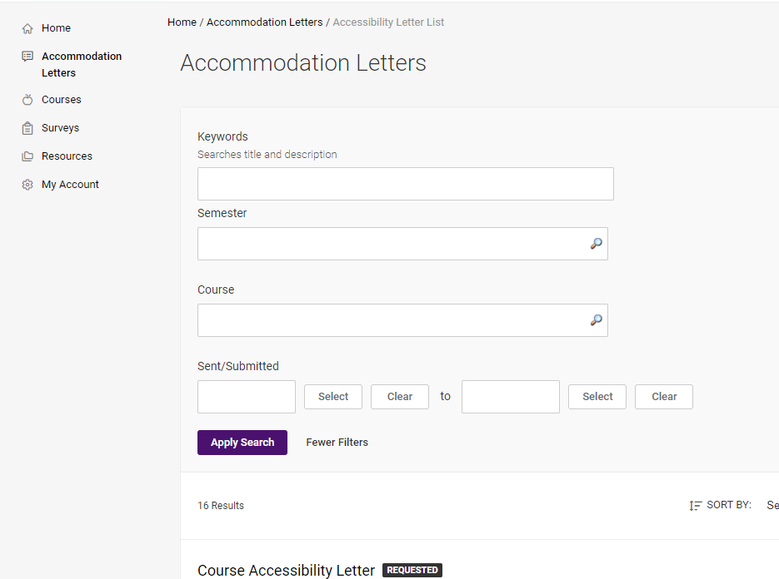

Step 4: Select the letter you wish to review by clicking on the “Course Accessibility Letter” link. Once you have reviewed and signed the letter you can print it through this screen. Signing the letter identifies that you have read the letter and understand the faculty role (if you have questions, connect with Student Accessibility Services as soon as possible). The accommodations are to be provided regardless of your signature.
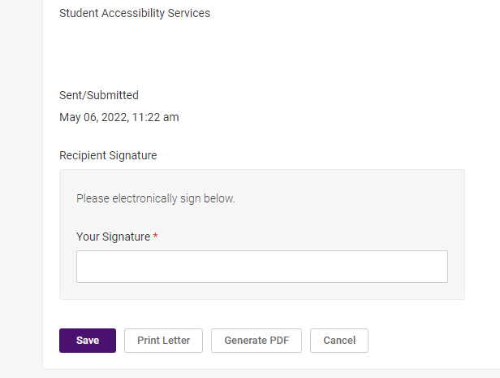

Step 5: Connect with Student Accessibility Services with any questions or concerns.

Step 6: Implement the Accommodations.

